# Project 2 - Gossip Simulator

## Team members -

Swaathi Reena Velavan - 12308520

Kasiviswanathan Srikant Iyer - 52222519

## In this Project, we have implemented two algorithms

1. The Gossip algorithm
2. Push-Sum algorithm

We have implemented both these algorithms for four topologies: - Full, Line, 3D, Imperfect 3D.

## Running the Code

*dotnet fsi --langversion:preview project.fsx  N T Algorithm*

Where N is the number of nodes, T is the topology

(topo= "full", topo= "2D", topo= "line", topo= "imp2D"),

A is the algorithm (algorithm = "gossip" or "push-sum")

Results

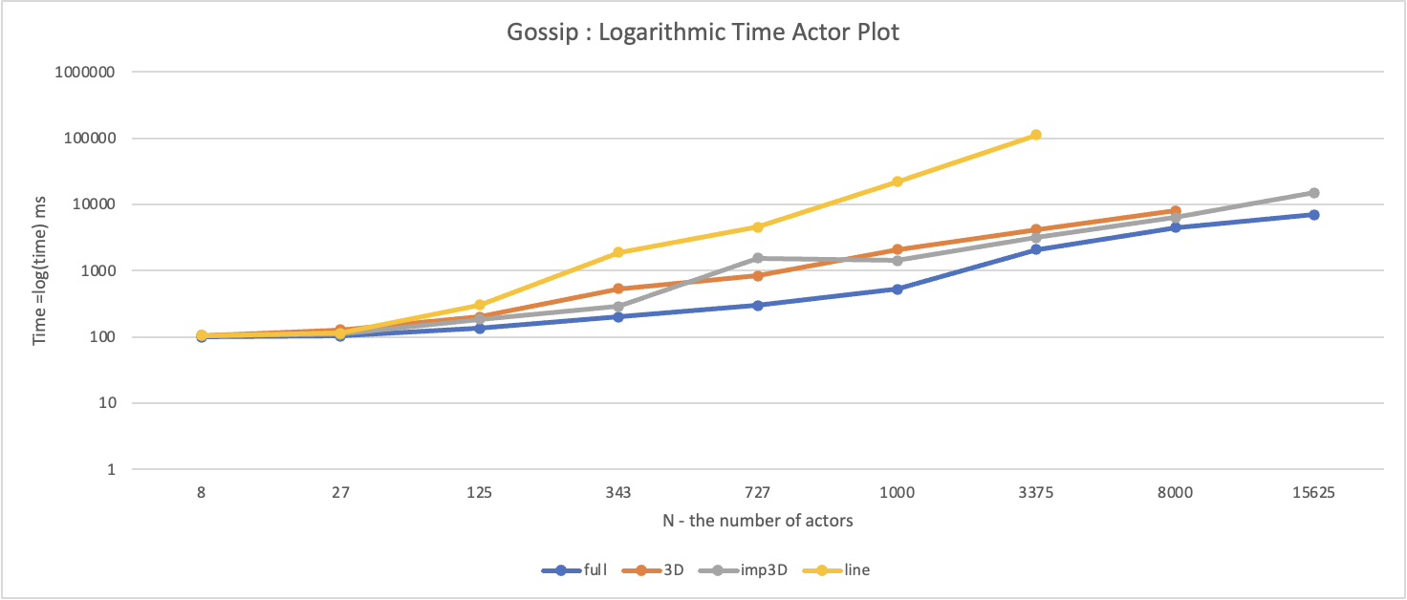

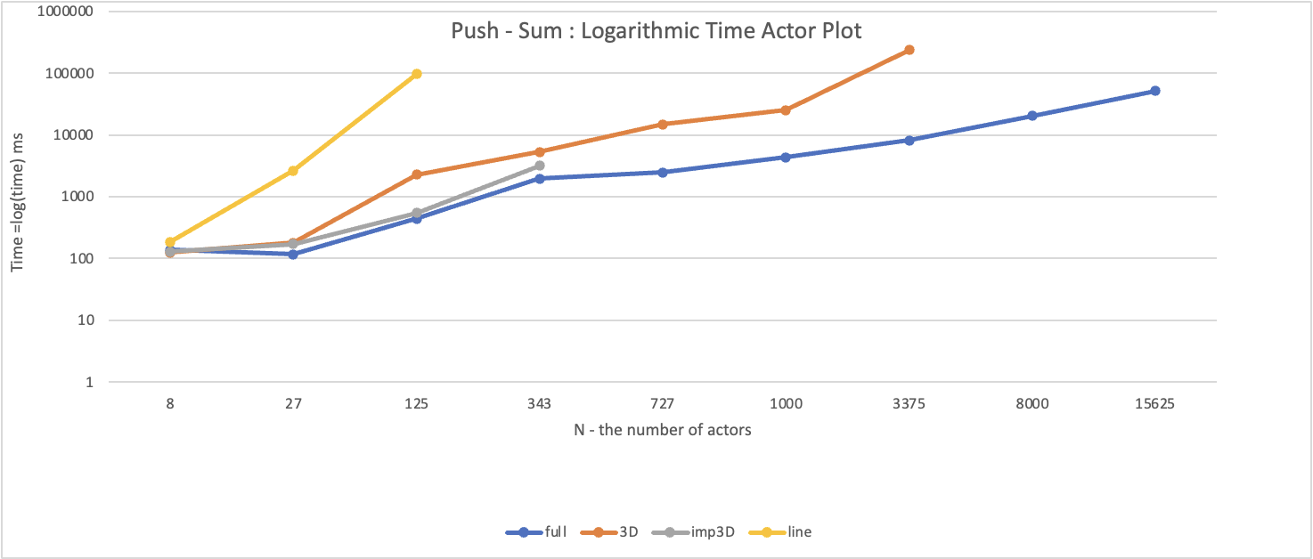

Observations

* In both algorithms, we observe that line topology takes more time to converge than all other topologies.
* In both algorithms, we observe that full topology is the fastest to converge among other topologies.
* Improper 3D is faster than 3D topologies.
* In 3D topology, if the number of nodes is not a perfect cube, the probability of the last node getting trapped in between dead actors is higher compared to all other actors.
* In improper 3D, the time taken is smaller compared to 3D topology, because of random actor jumps which help it to cover a larger number of actors without traversing the cube.